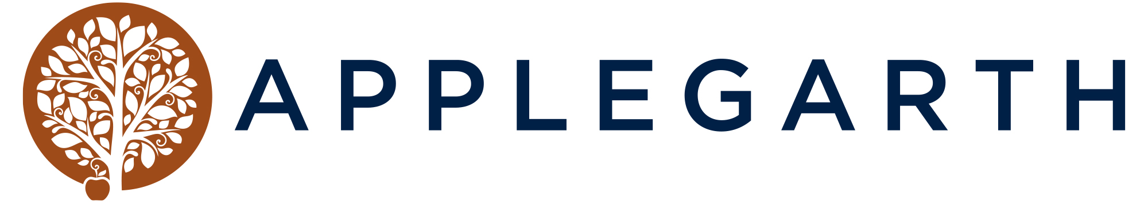

LUNCH MENU
Sun 12:30-3:30 — Tues-Sat 12-3
Nibbles & Starters
Smoked Almonds £4 Ⓥ Marinated Olives £4 GF -VE Ⓥ
Bread Board Aioli, Olive Oil & Balsamic £6 GFOA - VE
Sri lanken Vegetable Samosas, Apricot and Shallot Chutney £7 VE
Garlic & Chilli Prawns Charred Bakery Bread £8 GFOA
Soup of the Day Bakery Bread & Butter £10 VE - GFOA

Mains
Applegarth Curry Marinated Prawns, Jasmine Rice, Crispy Shallot Bhaji, Apricot Chutney & Charred Lime £20 GFOA
Wild Mushrooms on Toast Herby Mushrooms, White Wine Cream Sauce,
Poached Egg, Herb Oil £12 GFOA-VE
Chargrilled Aubergine or Lamb Rump
Tahini Yogurt, Pomegranate, Local Asparagus £14 | £20 VE GF Add New Potatoes £2.5
Catch Of The Day Chalk Stream Trout, Lemon & Herb Aioli, Seasonal Greens, Crushed New Potatoes £20 GFOA
Chicken Schnitzel Romesco Sauce, Leek Oil, Local Asparagus &
Heritage Courgette, £15.5 VE
Hot Smoked Trout Jammy Boiled Eggs, House Pickled Vegetables, Roasted Pear, Sesame & Spring Onion, Toasted Donker Rye & Dressed leaves £16 GFOA
Chicken Burger Brioche Bun, Lemon Aioli, Smoked Cheddar,
Garnish, Fries & Slaw £16 GFOA
Beef Burger Two 4oz Handmade Patties, Brioche Bun, Applemac Sauce, Smoked Cheddar,
Garnish, Fries & Slaw £16.5 GFOA

Sides
Aspen Fries Truffle Oil, Parmesan & Parsley £5.5 All VE

Celeriac Salad Rocket, Pickled Red Cabbage, Roast Celeriac Walnuts & Goats Cheese £5
Toasted Grain Salad Tahini Dressed Red Quinoa & Bulgar Wheat,
Tomato, Cucumber & Mint £5

ToatDesserts

Tarte au Citron Blueberry & Cardamon Compote £7.5 VE
Double Chocolate Sponge Pudding Chocolate Fudge Sauce £7.5
Affogato Espresso, Ice Cream & Biscuits £6.5 Add a shot of Hazelnut Liqueur £3 VE
Meadow Cottage Ice Cream 1 Scoop £2.50 - 2 Scoop £5 - 3 Scoop £7 VEO
Cheese Board Create your own Cheeseboard, Served with Artisan Crackers,
Chutney & Fruit 2 for £9 3 for £13 GFOA

Ⓥ Vegan / GF - Gluten Free / GFO - Gluten Free Option / DF - Dairy Free / DFO - Dairy Free Option |VE - Vegetarian Please speak to our staff before ordering you have and allergies and/or intolerances. OPTIONAL SERVICE CHARGE 12.5%

CHEESES

HARD
Old Winchester hard & crystalline with nutty notes, Salisbury
Ashcombe Morbier-inspired, savoury with warm hay & hazelnut aromas, Gloucestershire
Cornish Yarg Red Semi Hard Cheese, Fresh Taste, Wrapped in Nettle Leaves, Cornwall
Sparkenhoe Red Leister Nutty, Sweet, with a citrus finish, Warwickshire
Wyfe of Bath Succulent, Nutty & Creamy, Somerset

SOFT
Baron Bigod creamy white & raw, brie style, Suffolk
Delice De Borgogne A Decadent triple cream cheese, smooth & velvety, France

BLUE

Montagnolo A smooth, soft blue veined, with a creamy piquant flavour, Germany
Oxford Blue soft and full flavoured with a sharp clean flavour, Oxfordshire
Shropshire Blue Creamy Taste, delicately smooth & sweet, Nottinghamshire
Colston Basset Rich & Creamy with a Mellow Strong flavour
Gorgonzola Rich & Creamy, a soft buttery blue, Italy

GOAT & SHEEP

Rachel Goat classic hard goat’s cheese, smooth texture, sweet flavour
Spenwood smooth sheep cheese with a sweet & nutty flavour,

Ⓥ Vegan / GF - Gluten Free / GFO - Gluten Free Option / DF - Dairy Free / DFO - Dairy Free Option |VE - Vegetarian Please speak to our staff before ordering you have and allergies and/or intolerances.
OPTIONAL SERVICE CHARGE 12.5%

